CSE423 Project

Group: 09

Section: 05

Fall 2022

Project Name: Connect 4 Game

**Group Members:**

* Swapnil Majumder – 19101572
* Sabrina Tabassum – 22241158
* Md. Ridwan Mahmud - 19101104

In this project, we are trying to recreate the Connect 4 game on the Google Colab Platform. In case you forgot about this famous indoor game; a picture and a video link has been given below. 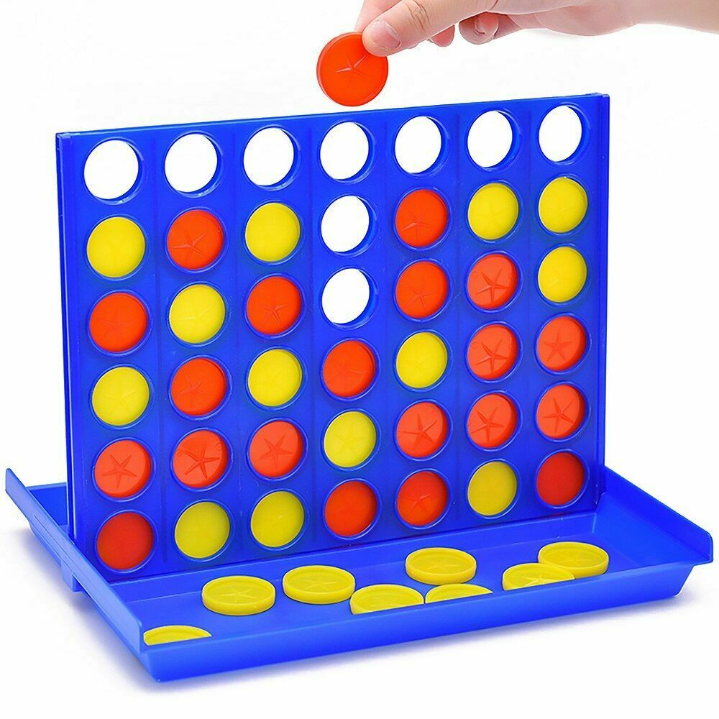

<https://youtu.be/ylZBRUJi3UQ>

We have used the concepts of **Transformation** to create this game. Firstly, the grid was made using the concept of translation. **The Midpoint Line Algorithm** has been used here to get the points of a vertical line. Later on, the concept of **Rotation** was used. The vertical line was rotated 90 degrees to get the horizontal line and those points were saved as well. 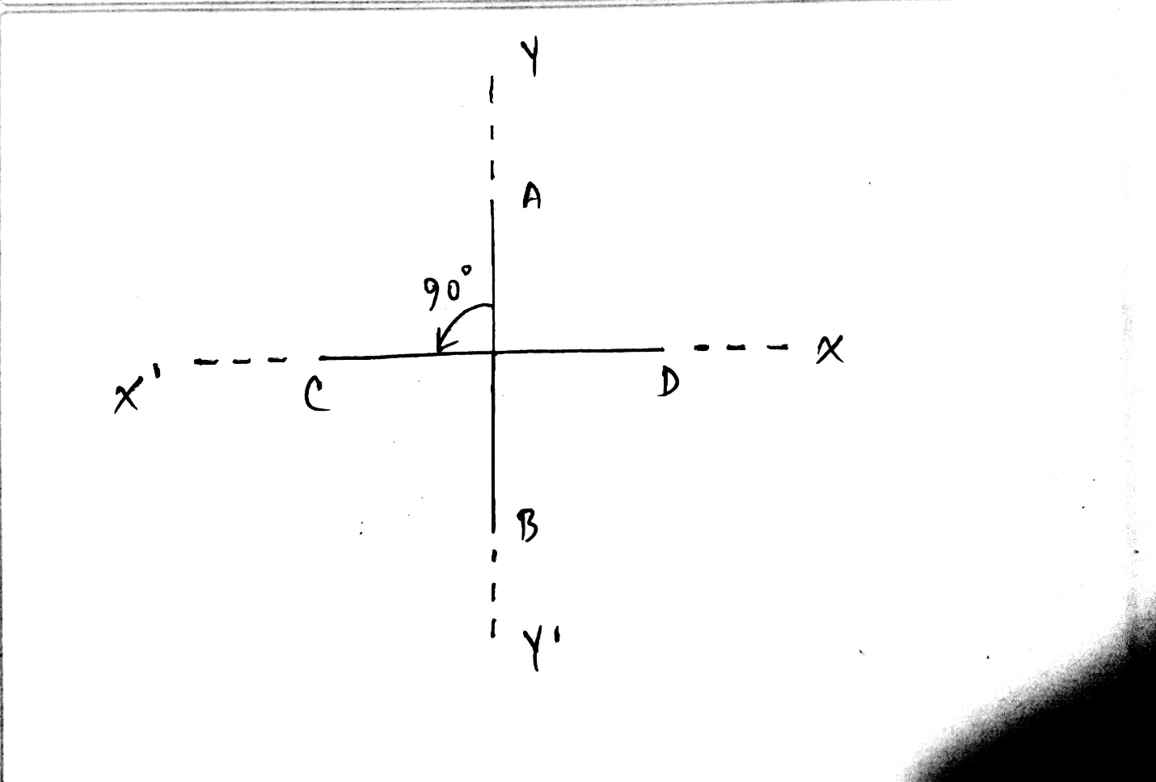

Later on, using the concept of **Translation**, we used the points we got previously to draw the vertical and horizontal lines on the screen after translating them to different equal distances. 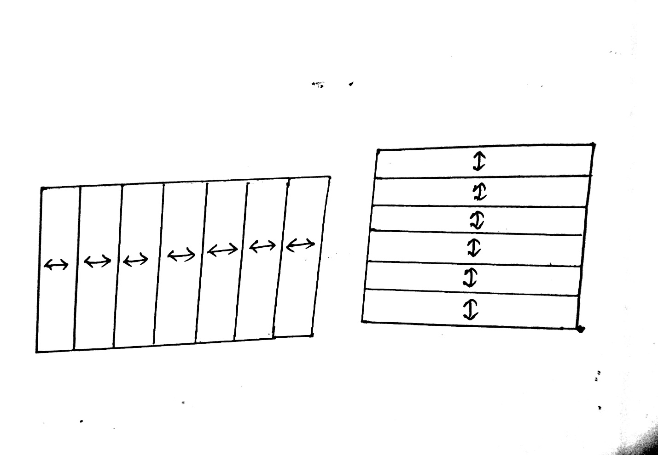

This makes the lines of the grid of the game with both of them combined. These lines give us 7 columns and 6 rows which is basically a 6x7 matrix.

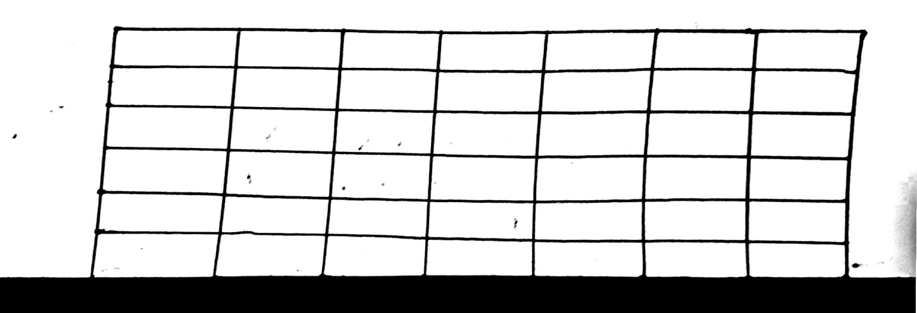

After the lines were drawn, we used the **Midpoint Circle Algorithm** to get the points of a circle in the middle of the axis where the center is (0,0).

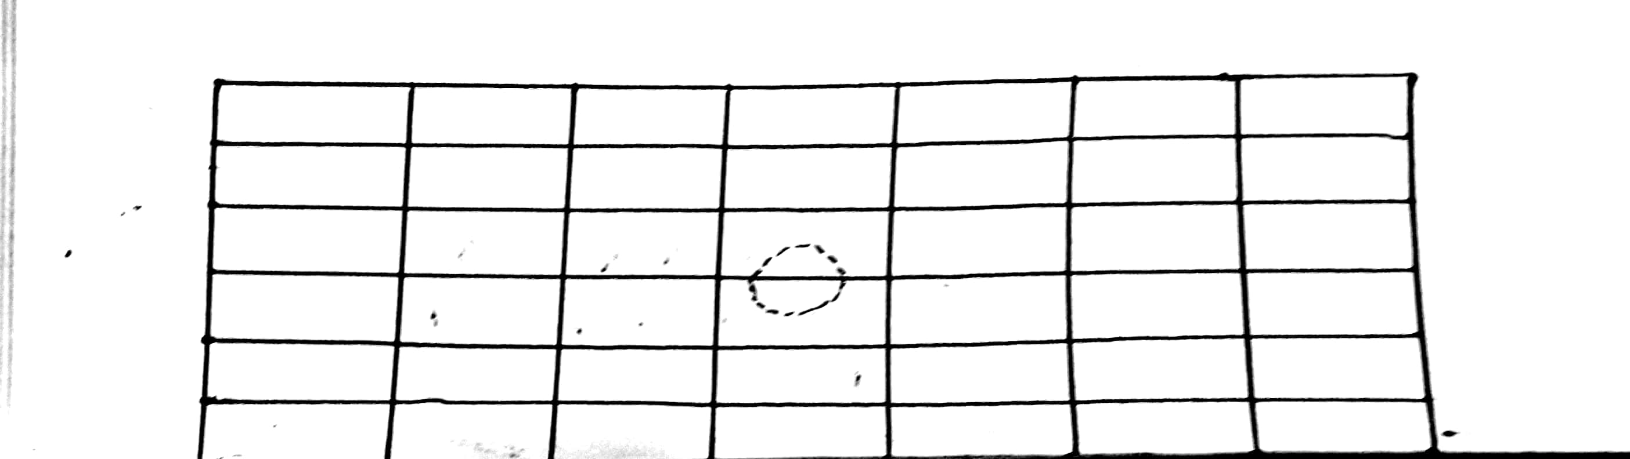

Later on, this circle was **translated** accordingly to fit in a box made by the lines. There is total 42 (6x7) boxes here.

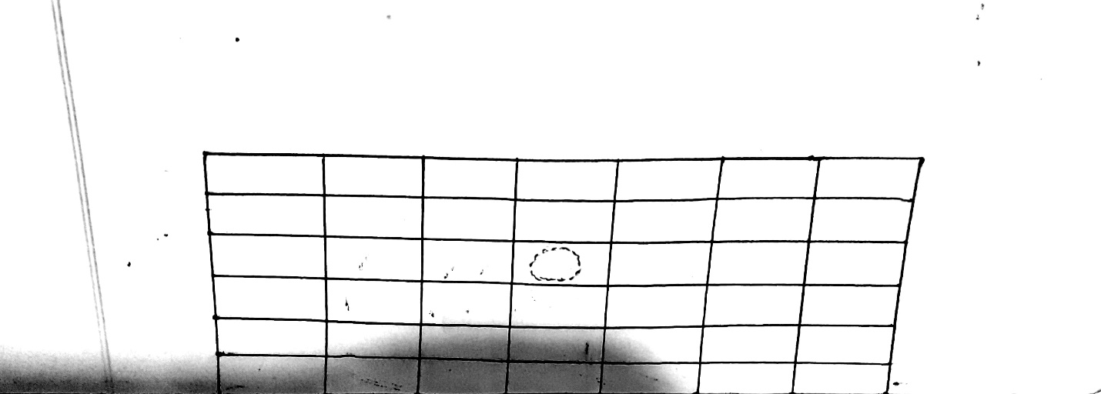

Later on, the points of the circle were used to draw the circles in all the 42 boxes accordingly using Translation again. This made the full grid of the game.

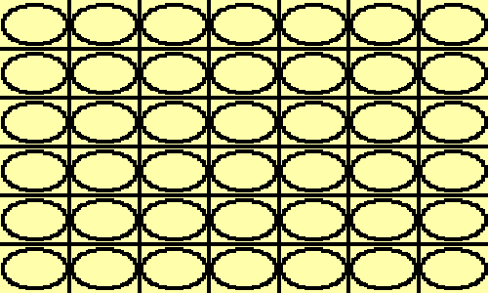

There are two player and when any of them chooses a column, the circle is filled with a color. Here, the concept of **reflection** was used to fill the circle. The points of the zone of circle were already saved. Then the reflecting points were chosen and they were drawn. Thus the whole circle gets filled up.

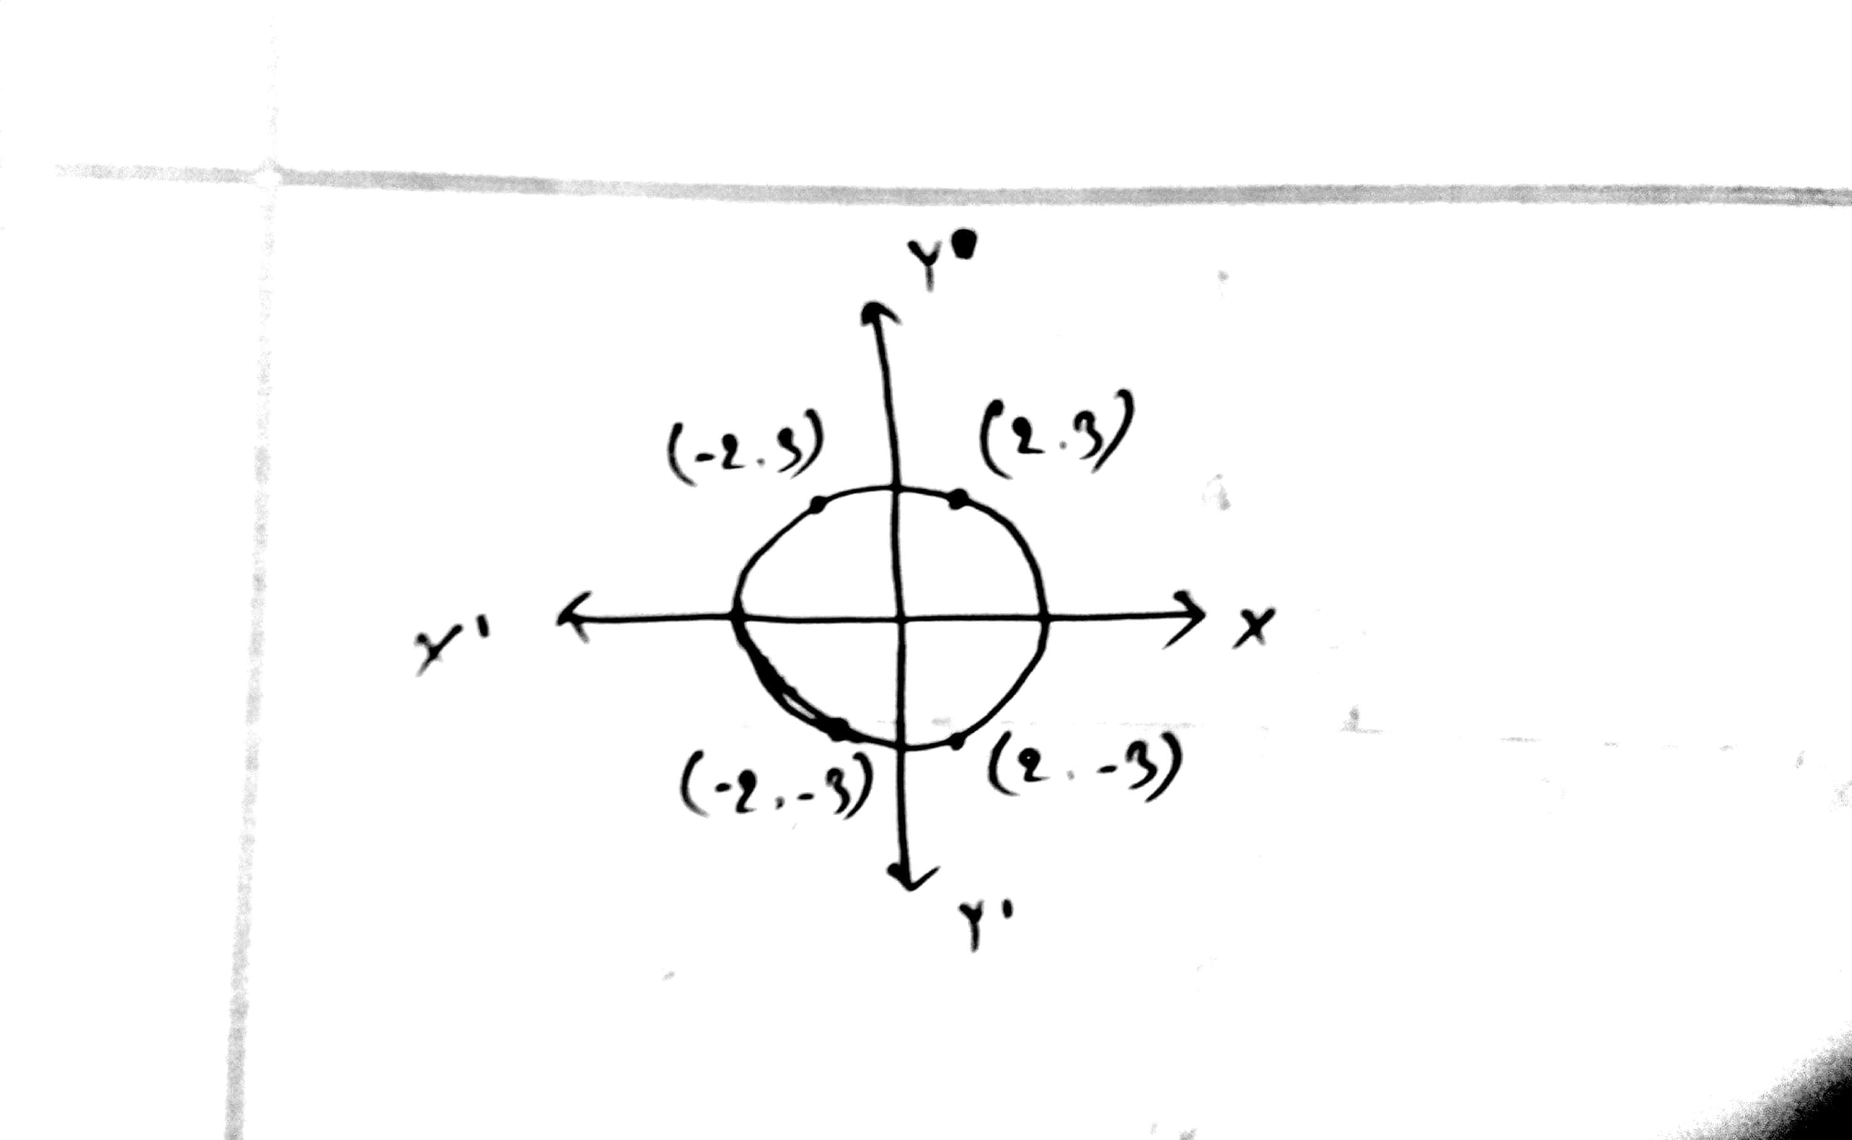

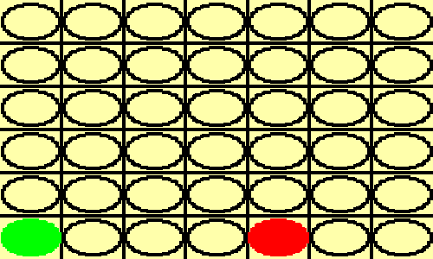

When 4 points matches in a row, the game is over. Whoever gets them first will win. There are methods to check if 4 circles are in a row. They check column-wise, row-wise and diagonally.

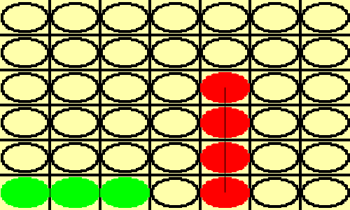

Here the red circle user wins.

This is basically the project. Thank you.